Cellular network

Cellular network is an underlying technology for mobile phones, personal communication systems, wireless networking etc. The technology is developed for mobile radio telephone to replace high power transmitter/receiver systems. Cellular networks use lower power, shorter range and more transmitters for data transmission.

## **Features of Cellular Systems**

Wireless Cellular Systems solves the problem of spectral congestion and increases user capacity. The features of cellular systems are as follows −

* Offer very high capacity in a limited spectrum.
* Reuse of radio channel in different cells.
* Enable a fixed number of channels to serve an arbitrarily large number of users by reusing the channel throughout the coverage region.
* Communication is always between mobile and base station (not directly between mobiles).
* Each cellular base station is allocated a group of radio channels within a small geographic area called a cell.
* Neighboring cells are assigned different channel groups.
* By limiting the coverage area to within the boundary of the cell, the channel groups may be reused to cover different cells.
* Keep interference levels within tolerable limits.
* Frequency reuse or frequency planning.
* Organization of Wireless Cellular Network.

Cellular network is organized into multiple low power transmitters each 100w or less.

## **Shape of Cells**

The coverage area of cellular networks are divided into **cells**, each cell having its own antenna for transmitting the signals. Each cell has its own frequencies. Data communication in cellular networks is served by its base station transmitter, receiver and its control unit.

The shape of cells can be either square or hexagon −

### **Square**

A square cell has four neighbors at distance **d** and four at distance Root **2 d**

* Better if all adjacent antennas equidistant
* Simplifies choosing and switching to new antenna

### **Hexagon**

A hexagon cell shape is highly recommended for its easy coverage and calculations. It offers the following advantages −

* Provides equidistant antennas
* Distance from center to vertex equals length of side

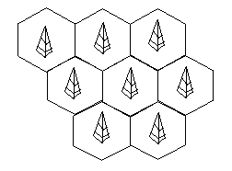

## **Frequency Reuse**

Frequency reusing is the concept of using the same radio frequencies within a given area, that are separated by considerable distance, with minimal interference, to establish communication.

Frequency reuse offers the following benefits −

* Allows communications within cell on a given frequency
* Limits escaping power to adjacent cells
* Allows re-use of frequencies in nearby cells
* Uses same frequency for multiple conversations
* 10 to 50 frequencies per cell

For example, when **N** cells are using the same number of frequencies and **K** be the total number of frequencies used in systems. Then each **cell frequency** is calculated by using the formulae **K/N**.

In Advanced Mobile Phone Services (AMPS) when K = 395 and N = 7, then frequencies per cell on an average will be 395/7 = 56. Here, **cell frequency** is 56.

# Cellular System Infrastructure

Early wireless systems had a high-power transmitter, covering the entire service area. This required a very huge amount of power and was not suitable for many practical reasons.

The cellular system replaced a large zone with a number of smaller hexagonal cells with a single BS (base station) covering a fraction of the area. Evolution of such a cellular system is shown in the given figures, with all wireless receivers located in a cell being served by a BS.

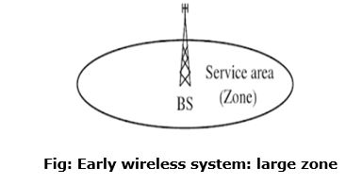  
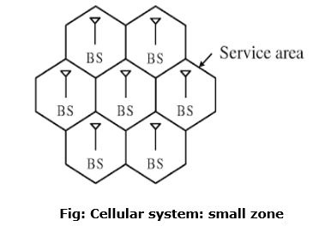

Wireless devices need to be supported for different types of services, the wireless device could be a wireless telephone laptop with wireless card, personal digital assistant (PDA), or web enabled phone. For simplicity, it could be called an MS.

In a cellular structure, a MS (mobile station) needs to communicate with the BS of the cell where the MS is currently located and the BS acts as a gateway to the rest of the world. Therefore, to provide a link, the MS needs to be in the area of one of the cells (and hence a BS) so that mobility of the MS can be supported. Several base stations are connected through hard-wires and are controlled by a BS controller (BSC), which in turn is connected to a mobile switching center (MSC).

Several mobile switching centers are interconnected to a PSTN (public switched telephone network) and the ATM (asynchronous transfer mode) backbone. To provide a better perspective of wireless communication technology, simplified system infrastructure for cellular system is shown in the figure:

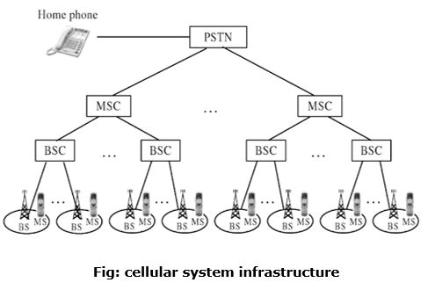

A cellular system requires a fairly complex infrastructure. A generic block diagram in shown in the figure:

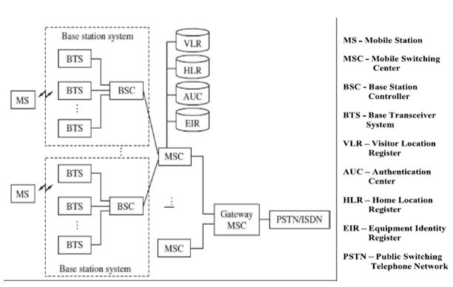

A BS consists of a base transceiver system (BTS) and a BSC. Both tower and antenna are a part of the BTS, while all associated electronics are contained in the BSC.

The HLR (home location register) and VLR (visitor location register) are two sets of pointers that support mobility and enable the use of the same telephone numbers worldwide.

The AUC (authentication center) unit provides authentication and encryption parameters that verify the user's identity and ensure the confidentiality of each cell.

The EIR (equipment identity register) is a database that information about identity of mobile equipment. Both AUC and EIR can be implemented as individual stand-alone units or as a combined AUC/EIR unit.

The HLR is located at the MSC where MS is initially registered and is the initial home location for billing and access information.

In simple words, any incoming call, based on the calling number, is directed to the HLR of the home MS where the MS is registered. The HLR then points to the VLR of the MSC where the MS is currently located.

Bidirectional HLR-VLR pointers help in carrying out various functionalities, as illustrated in the figure:

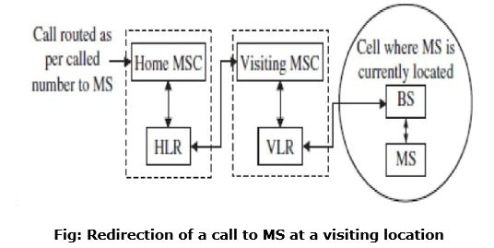

The VLR contains information about all MS visiting that particular MSC and hence points to the HLR of the visiting MSs for exchanging related information about the MS.

Such a pointer allows calls to be routed or rerouted to the MS, wherever it is located. In cellular systems, a reverse direction pointer is needed that allows traversal of many control signals back and forth between the HLR and VLR such bidirectional HLR-VLR pointers help in carrying out various functionalities.

..........................................................................................................................................................

**Difference between Cellular and Wi-Fi Networks**

Cellular Network:

Cellular Network is formed of some cells, cell covers a geographical region, has a base station analogous to 802.11 AP which helps mobile users attach to network and there is an air-interface of physical and link layer protocol between mobile and base station. All these base stations are connected to Mobile Switching Center which connects cells to wide area net, manages call setup and handles mobility.

Wi-Fi:

It is stands for Wireless Fidelity. It is a technology for wireless local area networking with devices based on IEEE 802.11 standards. Wi-Fi compatible devices can connect to the internet via WLAN network and a wireless access point abbreviated as AP. Every WLAN has an access point which is responsible for receiving and transmitting data from/to users.

**Difference between Cellular and Wi-Fi Networks:**

| S.NO. | CELLULAR | WI-FI |
| --- | --- | --- |
| 1 | Cellular plan are attached to the device that uses cellular signal to connect to the internet. | Wi-Fi is a local area networking technology that uses radio waves to provide high-speed internet access to mobile devices enabled with Wi-Fi. |
| 2 | Cellular refers to a mobile network which is distributed over a wide area. | Wi-Fi is a critical element and a crucial wireless networking technology based on the IEEE 802.11 standards. |
| 3 | Cellular has no limit in the range. | Wi-Fi has a limited range. |
| 4 | Mobile technology is the technology used for cellular communication. | Device can use the Wi-Fi standard to broadcast and receive information. |
| 5 | Cellular has a data plans with limited consumption. | Wi-Fi has no limit on how much data you can use in a day or a month. |
| 6 | Cellular network are relatively slow in terms of speend and reliability. | Wi-Fi are faster than Cellular Network.. |

……………………………………………………………………………………………………………………………

## **What is GSM?**

GSM stands for **G**lobal **S**ystem for **M**obile Communication. It is a digital cellular technology used for transmitting mobile voice and data services. Important facts about the GSM are given below −

* The concept of GSM emerged from a cell-based mobile radio system at Bell Laboratories in the early 1970s.
* GSM is the name of a standardization group established in 1982 to create a common European mobile telephone standard.
* GSM is the most widely accepted standard in telecommunications and it is implemented globally.
* GSM is a circuit-switched system that divides each 200 kHz channel into eight 25 kHz time-slots. GSM operates on the mobile communication bands 900 MHz and 1800 MHz in most parts of the world. In the US, GSM operates in the bands 850 MHz and 1900 MHz.
* GSM owns a market share of more than 70 percent of the world's digital cellular subscribers.
* GSM makes use of narrowband Time Division Multiple Access (TDMA) technique for transmitting signals.
* GSM was developed using digital technology. It has an ability to carry 64 kbps to 120 Mbps of data rates.
* Presently GSM supports more than one billion mobile subscribers in more than 210 countries throughout the world.
* GSM provides basic to advanced voice and data services including roaming service. Roaming is the ability to use your GSM phone number in another GSM network.

GSM digitizes and compresses data, then sends it down through a channel with two other streams of user data, each in its own timeslot.

## **Why GSM?**

Listed below are the features of GSM that account for its popularity and wide acceptance.

* Improved spectrum efficiency
* International roaming
* Low-cost mobile sets and base stations (BSs)
* High-quality speech
* Compatibility with Integrated Services Digital Network (ISDN) and other telephone company services
* Support for new services